**Computer Engineering**

**EGCP 470 MULTIDISCIPLINARY PROJECTS FALL 2018**

**IN COMPUTER ENGINEERING – I**

**FORMAL PROJECT REPORT**

**VOICE CONTROLLED SHOWER**

**CORY LONGSHORE**

**JAMES PEREZ**

**HUGO SIMON**

**JESSICA DIAZ**

**TABLE OF CONTENTS PAGE**

**ABSTRACT** **2**

**BACKGROUND** **2**

**DESIGN GOALS** **2**

**DESIGN SPECIFICATION** **3**

**BLOCK DIAGRAM AND FUNCTIONAL EXPLANATION** **4**

**FLOW CHART** **5**

**SCHEMATICS** **6**

**PARTS LIST** **8**

**PHOTOS** **9**

**DISCUSSION OF RESULTS** **10**

**PROBLEMS ENCOUNTERED** **10**

**INDIVIDUAL TASK ASSIGNMENTS** **10**

**CONCLUSION** **11**

**FUTURE WORK** **11**

**REFERENCES** **12**

# 

# 

# ABSTRACT

For our Senior Design we will be designing and building a motorized track to operate a shower by use of voice recognition and a controller. Our device should be able to control a shower head on a motorized track as well control the temperature of the water. To accomplish this we will be implementing the voice controls by interfacing with Alexa, Amazon’s AI, through the use of an Amazon Echo. The use of AWS Lambda, which is Amazon’s Web Service, will enable us to use our Arduino to communicate between the devices in order to activate the stepper motors that will be utilized for the functionality of our design.

# BACKGROUND

Our inspiration for this project came from an ALS patient who suffers from a progressive neurodegenerative disease that affects nerve cells in the brain and the spinal cord. This causes diminishing motor functions and limits mobility which requires the need for constant assistance. This inspired our design to try and improve the quality of life for anyone that requires assistance to do simple tasks, such as taking a shower. Our goal is to have the voice controls assist the user and remove the need for any additional help while showering. This would be beneficial for the elderly or anyone with disabilities that restricts their motor functions.

# DESIGN GOALS

Our goal is to design and build a voice controlled shower that is able to assist anyone that suffers from limited mobility or has any type of restriction of movement.The design of our shower is to be voice enabled through the use of an Alexa as well as an optional control through an app.We want to include functions to adjust the position of the shower head, change the temperature of the water, and have user recognition to enable custom presets for each user.

# DESIGN SPECIFICATION

*CpE SO(2): An ability to apply engineering design to produce solutions that meet specified needs with consideration of public health, safety, and welfare, as well as global, cultural, social,   
environmental, and economic factors

SO(2): Our project gives us the ability to design and conduct experiments, as well as to analyze and interpret data by challenging us to create and implement an IoT device with an Arduino. We will be writing code to send commands from our microcontroller to the external motors. The external components will execute their function and return control to the AI. The AI will then send feedback in order to implement a busy/wait system to control our household appliance.

* CpE SO(5): An ability to function effectively on a team whose members together provide leadership, create a collaborative and inclusive environment, establish goals, plan tasks, and meet objectives.

SO(5): It also gives us the ability to identify, formulate, and solve engineering problems by first brainstorming some type of problem that we can solve to be beneficial to the general population. Then, we came up with the idea to enable anyone with disabilities or limited movement the ability to require less assistance doing mundane tasks. The idea was to have a voice-enabled shower that would be able to control the shower and would possibly remove the need for extra assistance while in the shower. This solution to this problem is a quality of life improvement that many would consider very beneficial since it employs more self-dependence.

# BLOCK DIAGRAM AND FUNCTIONAL EXPLANATION

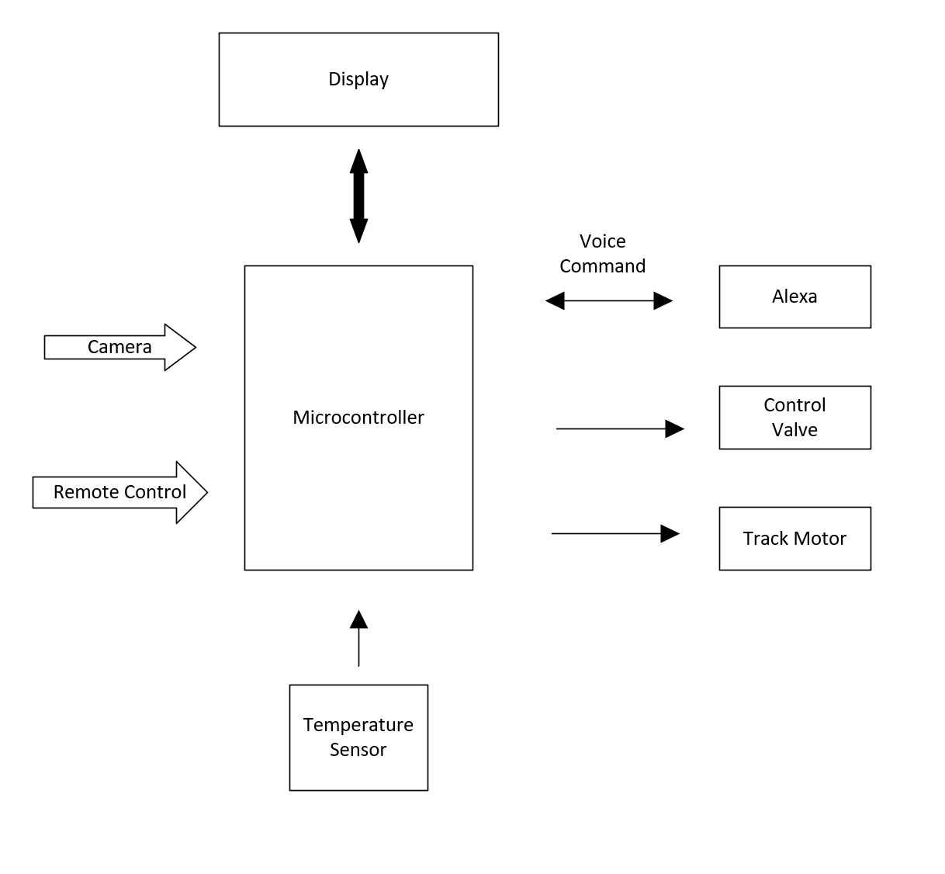

**Figure 1**

Fig. 1 contains the components that will allow the use of voice commands, user recognition, temperature control while also adjusting the water pressure.

# FLOW CHART

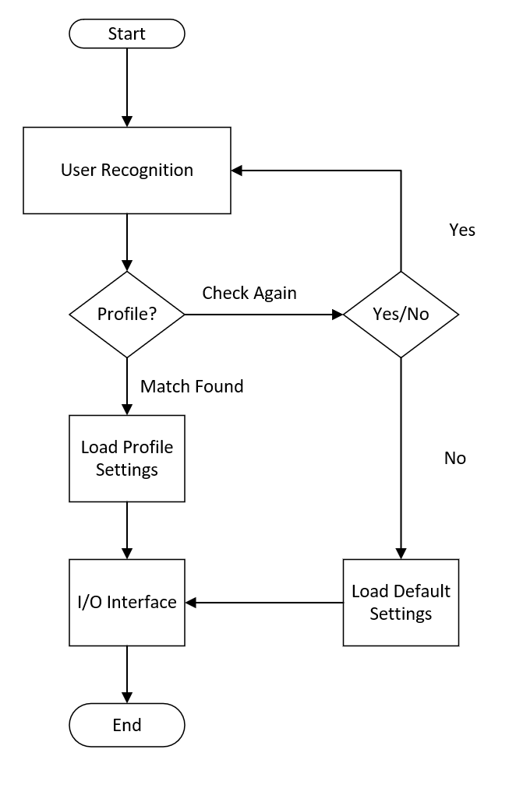

**Figure 2**

Fig. 2 shows the logic design that will be implemented. It starts when the user enters the bathroom and ends when the user enters the shower.

# SCHEMATICS

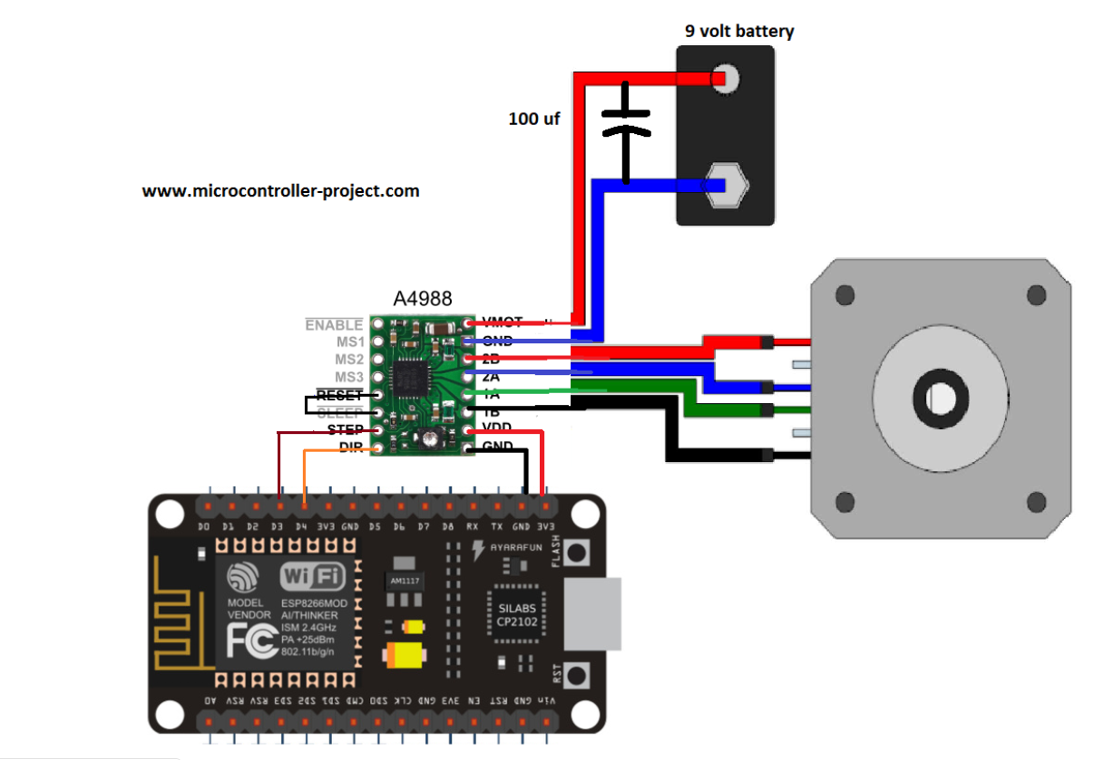

**Figure 3**

This schematic will help us control the shower head movement on the sliding track that will be able to reposition itself.

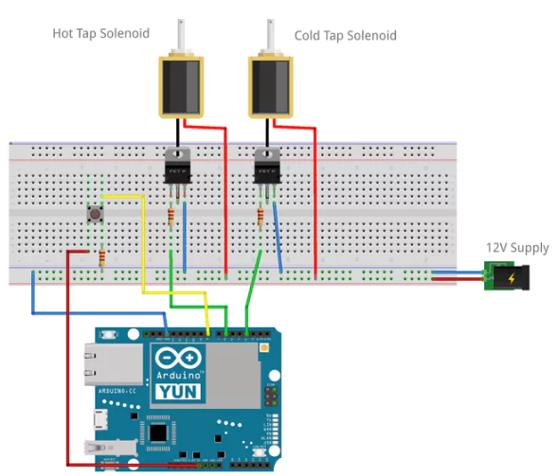

**Figure 4**

This schematic will help us control the control valves that will be opening and closing to adjust the temperature of the water as well as the water pressure.

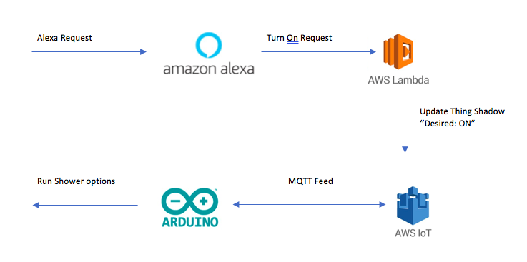

**Figure 5**

We are using the flowchart of Figure 5 to develop and interface our Alexa and Arduino code. The first step is to request Alexa your desired option for the shower, then it will send that request to AWS services, turn on the request, and finally interface it with the Arduino in order to complete the task.

# PARTS LIST

In the table below we have listed our current parts with costs of our project and we are currently under our preliminary budget of $1018.21.

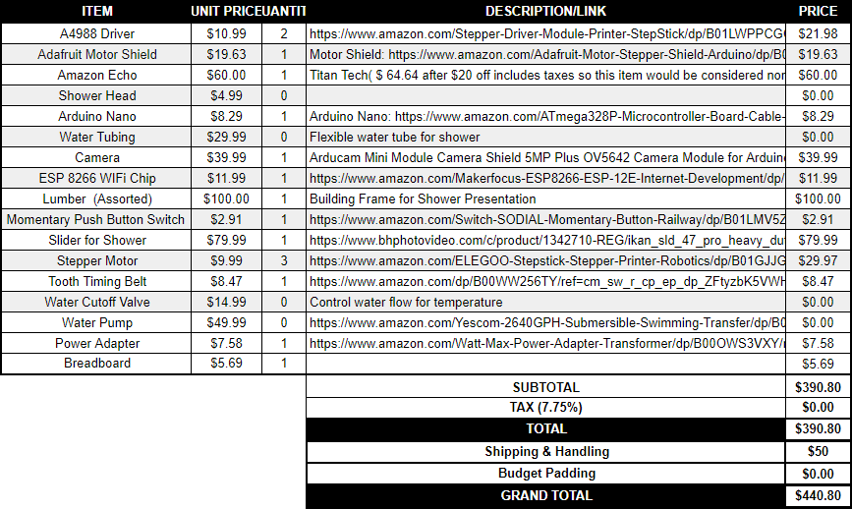

# 

# PHOTOS

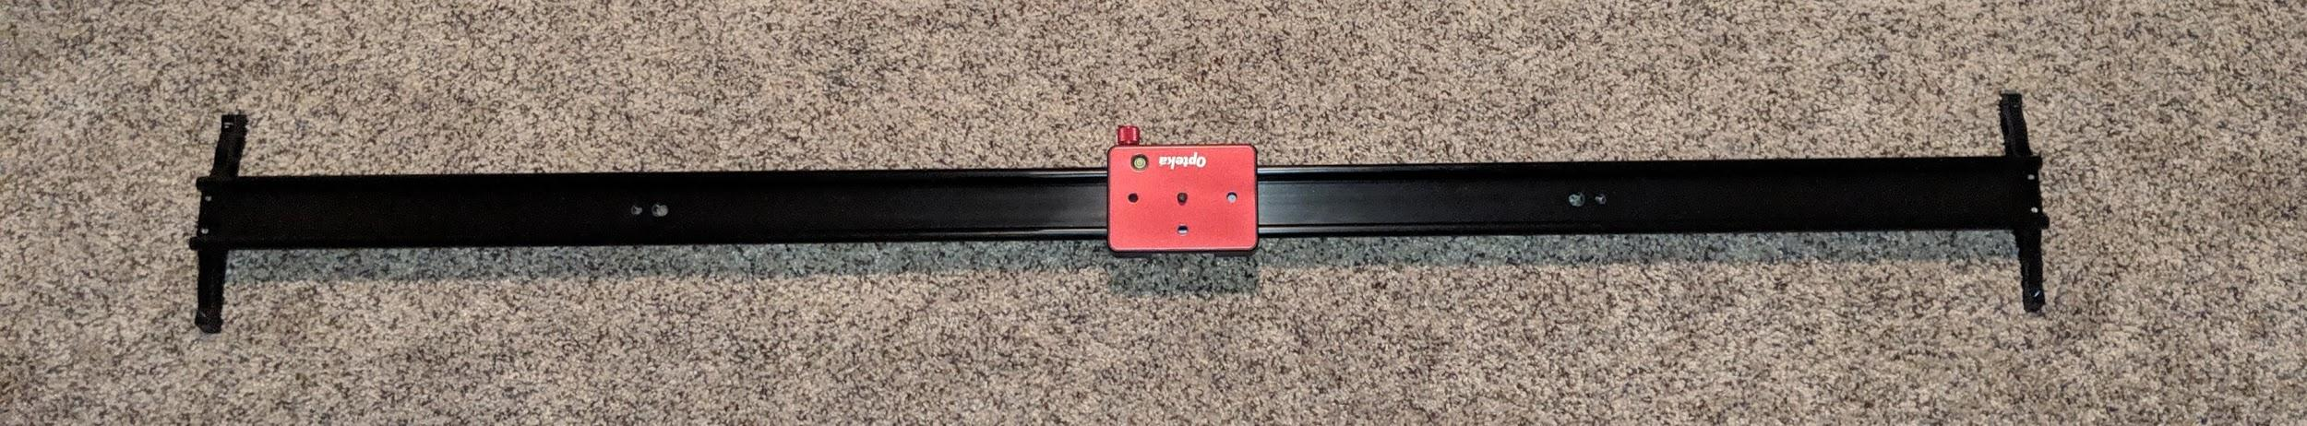

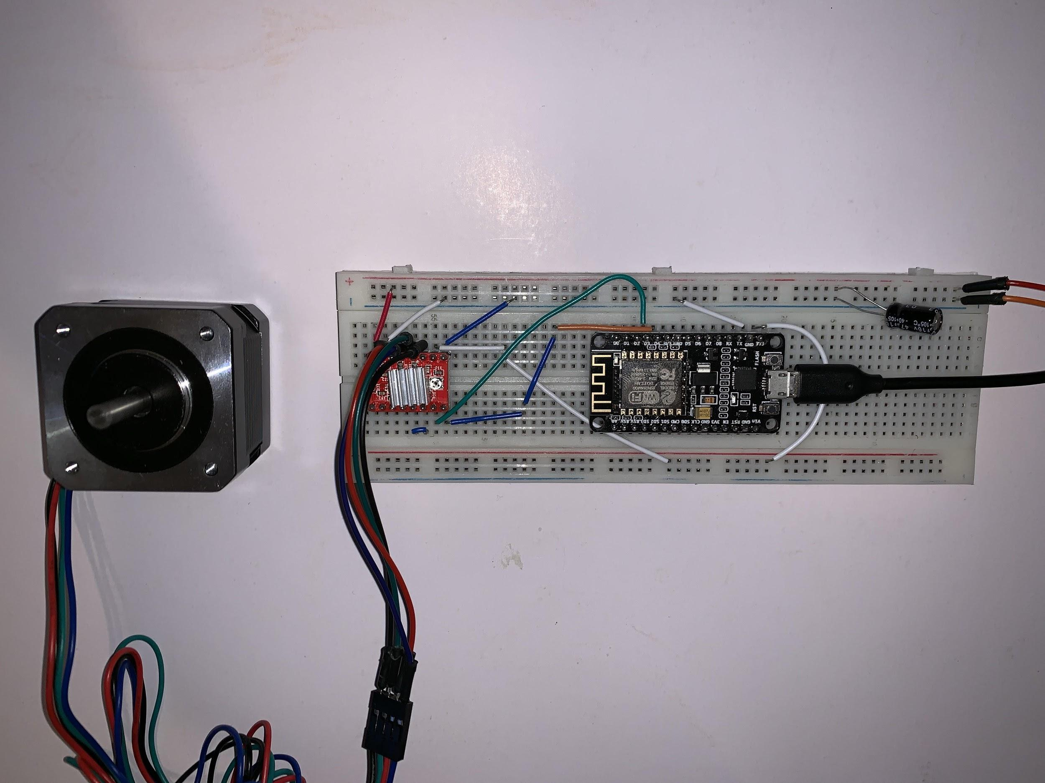

This first image is the slider that we will be attaching the shower head to, which will be assisted by the stepper motor in the second photo. We will be attaching both to the shower frame in order to enable the shower head to traverse the track with the use of voice commands. As of this report, we have yet to get all the software/coding potion working and therefore haven’t started to attach and hardware to the shower frame for testing. Most of this will be implemented as soon as the code it stable and working.

**DISCUSSION OF RESULTS**

So far we have the stepper motors working perfectly with our web based app and are ready to implemented on the track we are to build and mount on the demo shower. Our next step is to get the Alexa interfacing with the Arduino. After we will begin the next phase which will be controlling the valves in order to control the temperature of our shower. We will then continue and if we have time we will try to implement the facial recognition into our design.

# PROBLEMS ENCOUNTERED

The first problem we encountered was the design of the slider to move the shower head. In order to solve this problem we went through a couple different designs on how to best implement the movement of the shower head and settled with a modified camera slider. The second problem we encountered was that our schematic for the stepper motors was incorrect, we then had to do more research on the motor itself to find a procedure that would operate them correctly. Our third problem is integrating Arduino with Amazon’s web service using AWS Lambda. We are currently doing research on how to successfully upload our code to AWS so that we could publish the code to interface with Alexa and the Arduino.

# INDIVIDUAL TASK ASSIGNMENTS

James Perez - In charge of interfacing motors with Arduino/ESP8266 MCU 1.0 with webpage.

Hugo Simon - In charge of programming the hot and cold tap solenoids and helping with Alexa programming

Cory Longshore - In charge of building wooden frame for the demo shower as well as helping with Alexa programming

Jessica Diaz - In charge of interfacing Alexa with the Arduino using AWS services and helping with Alexa and Arduino programming.

# CONCLUSION

We are currently working on getting the Arduino interfaced with AWS Lambda so that we can start to write the code to configure the voice commands. Once we get the Arduino’s interfacing with the Amazon Echo device correctly, we will install the parts onto our shower frame and start running tests and diagnosing any issues that arise. After the shower movement is properly tuned, we will start working on installing the flow control valves to adjust the water temperature and install the sensor to provide a temperature readout for the user.

# FUTURE WORK

If we do not get facial recognition to properly work this semester, future work would include image recognition that would create a user profile on an app and save the users preferences for faster setup. These preferences would include water temperature, shower head position, and angle. For facial recognition to work dynamically, machine learning would be utilized in order to learn the face and preferences of each independent user. Additionally, we would want to articulate the head of the shower to move left and right, not just in a fixed position. Also, since this IoT project is marketable, we would then want to make the entire shower piece interchangeable with a standard shower. This would mean that anyone with a disability, or a person with limited mobility could utilize this system to shower independently. Undeniably, waterproofing is a difficult challenge for us with this task; in the future, tackling this would require extensive rewiring, gasket installations, as well as other waterproofing entities.

# REFERENCES

[1] **“DIY Motorized WiFi Camera Slider,” *Novaspirit*, 03-Jul-2017. [Online]. Available: https://www.novaspirit.com/2017/07/01/diy-motorized-wifi-camera-slider/. [Accessed: 10-Oct-2018].**

**[2] “Nodemcu Stepper Motor Control Over WiFi,” Microcontroller Projects. [Online]. Available:https://www.microcontroller-project.com/nodemcu-esp8266-stepper-motor-interfacing.html. [Accessed: 05-Oct-2018].**